**Name - Gaurang A Raorane Roll No - 49**

**Class - D15A Batch - C**

**EXPERIMENT 3**

**Aim :-** Write a program in Java or Python to perform Cryptanalysis or decoding Playfair Cipher.

import java.util.Scanner;

public class PlayFairCryptanalysis {

private static final int SIZE = 5;

private static char[][] keyMatrix = new char[SIZE][SIZE];

private static void initializeKeyMatrix(String key) {

key = key.toUpperCase().replaceAll("[J]", "I");

boolean[] visited = new boolean[26];

int row = 0, col = 0;

for (char c : key.toCharArray()) {

if (!visited[c - 'A']) {

keyMatrix[row][col] = c;

visited[c - 'A'] = true;

col++;

if (col == SIZE) {

col = 0;

row++;

}

}

}

for (char c = 'A'; c <= 'Z'; c++) {

if (c != 'J' && !visited[c - 'A']) {

keyMatrix[row][col] = c;

col++;

if (col == SIZE) {

col = 0;

row++;

}

}

}

}

private static String decrypt(String ciphertext) {

StringBuilder plaintext = new StringBuilder();

for (int i = 0; i < ciphertext.length(); i += 2) {

char c1 = ciphertext.charAt(i);

char c2 = ciphertext.charAt(i + 1);

int row1 = -1, col1 = -1, row2 = -1, col2 = -1;

for (int row = 0; row < SIZE; row++) {

for (int col = 0; col < SIZE; col++) {

if (keyMatrix[row][col] == c1) {

row1 = row;

col1 = col;

}

if (keyMatrix[row][col] == c2) {

row2 = row;

col2 = col;

}

}

}

if (row1 == row2) {

col1 = (col1 - 1 + SIZE) % SIZE;

col2 = (col2 - 1 + SIZE) % SIZE;

} else if (col1 == col2) {

row1 = (row1 - 1 + SIZE) % SIZE;

row2 = (row2 - 1 + SIZE) % SIZE;

} else {

int temp = col1;

col1 = col2;

col2 = temp;

}

plaintext.append(keyMatrix[row1][col1]);

plaintext.append(keyMatrix[row2][col2]);

}

return plaintext.toString();

}

public static void main(String[] args) {

Scanner scanner = new Scanner(System.in);

System.out.print("Enter the Playfair key: ");

String key = scanner.nextLine().toUpperCase().replaceAll("[^A-Z]", "");

initializeKeyMatrix(key);

System.out.print("Enter the ciphertext to decrypt: ");

String ciphertext = scanner.nextLine().toUpperCase().replaceAll("[^A-Z]", "");

String plaintext = decrypt(ciphertext);

System.out.println("Decrypted plaintext: " + plaintext);

scanner.close();

}

}

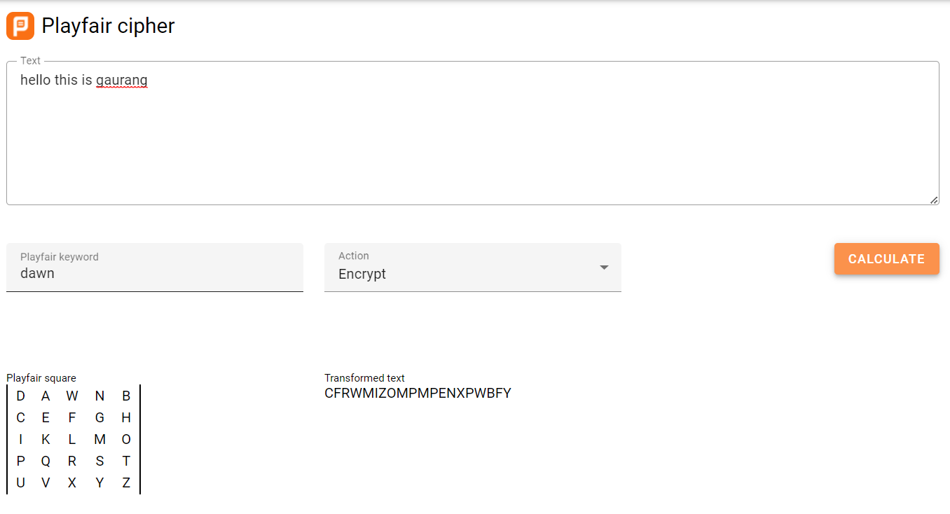

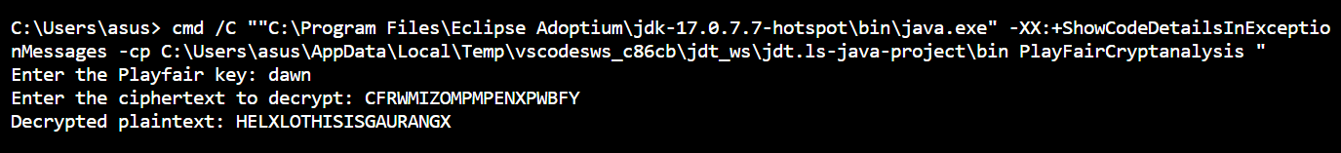

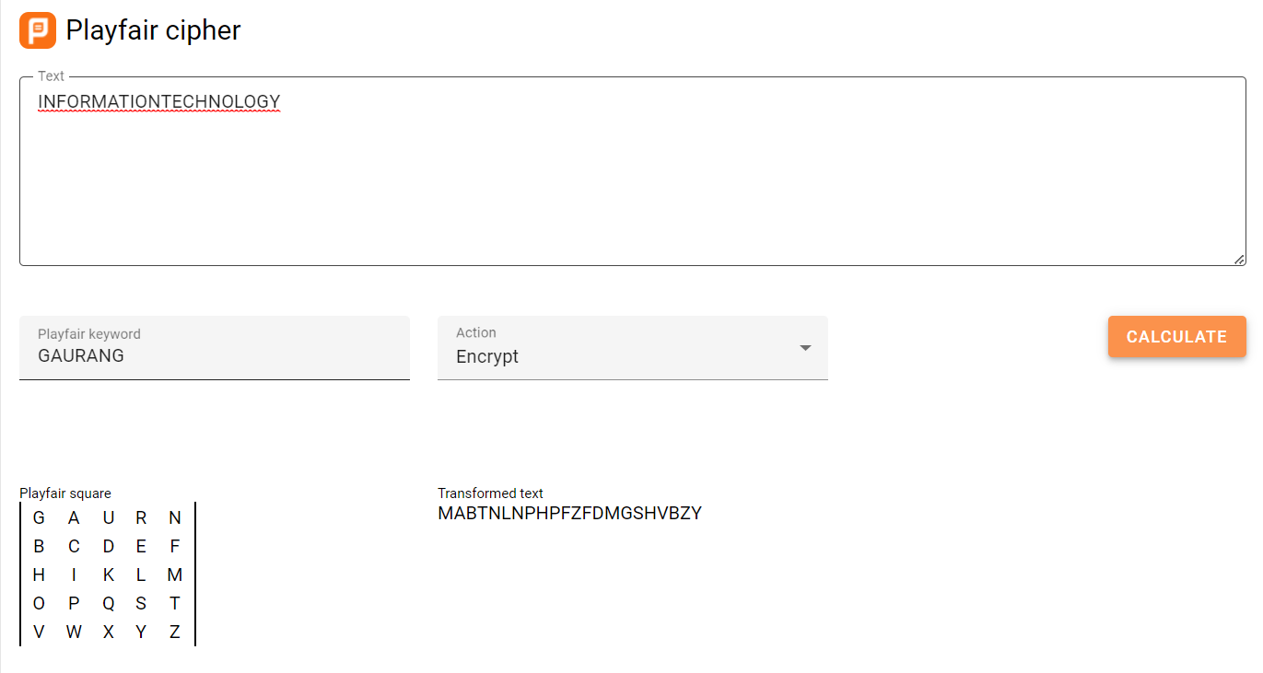



**Conclusion:-**

Decoding is successfully implemented using Playfair cipher.